Imperatives Intro + Map Game

Abstract: This is a 20- to 30-minute grammar activity intended to introduce the basic use of the imperative form in English. It includes a brief presentation of how to take a declarative sentence and turn it into an imperative, highlighting the “implied you” subject, the negative form, and imperatives with the verb “be.” Students then practice orally in pairs before moving on to a map game called “Drive Blind” in which each student gets to practice giving and receiving imperatives in order to arrive at various destinations as portrayed on the map. Finally, students reflect on their successes and identify challenges in using the imperative. Moving forward, students will be ready for additional (more advanced) information about using this form.

Purpose:
- To advance students’ grammatical knowledge of imperative structure;
- To implement this knowledge in a practical activity using teamwork;
- To learn something new about one’s city.
- To reflect on the activity, its difficulties and successes, and think about ways forward.

Specific objectives:
- To draw on students’ previous knowledge of the imperative form;
- To define basic imperative structure, the negative form, and “be” form;
- To interact with peers, at first orally and then in a more in-depth activity;
- To learn about actual locations in the city that students may or may not be familiar with;
- To practice prepositions of place.

Skills, competences, and/or literacies:
- ACTFL Communication 1.1: students work together in groups, exchanging information and opinions.
- ACTFL Connections 3.1: through the use of the English imperative, students further their knowledge of the city they live in via the map game.
- ACTFL Communities 5.1 (if in ESL context): students have the opportunity to use the target language outside the classroom by visiting the new locations learned through the map game.

Context: EFL/ESL classroom, high-beginner level.

Preparation: the instructor should ready a few examples of the basic imperative form, the negative, and imperatives with “be.” Additionally, the instructor should decide ahead of time whether to use an existing map or have the students create their own (if time permits). The latter option makes the activity more personalized to the given pair of students, but relies on students’ familiarity of the city; therefore it is more strongly suggested in the EFL than ESL context.

Implementation:
- Warm up by using the imperative with the group as a whole—for example, say “Student X, turn off the lights please; open your books to page X, take off your jackets,” etc. (1 minute)
- Assess their familiarity with the imperative form (“Have you used this before? What’s it called and why is it used?”). Present the basic imperative structure along with its negative form and “be” form. For example, start with a declarative statement like “I bring the book” and demonstrate the transformation to the imperative:

I bring the book.
____ Bring the book
(no sub / implied “you”) + verb is in base form.

Negative form:
I don’t bring the book.
Don’t bring the book.

w/”be”:
I am prepared.
Be prepared.
(3–5 mins)

- Elicit examples from students (in pairs, give each other a command, a negative command, and one with “be”). While students are doing this, put key terms for the game on the board, such as “turn/take a right, go straight/left/right/north” etc.. Also, write down some prepositions of place (next to, behind, in front of, between, to the east/west/north/south). (2 minutes)
- Optional step: create map (EFL context). Ask students to draw a map of about 5 square blocks of an area of the city they know well, one that has a lot of good restaurants. Include at least 4 or 5 restaurants in their approximate locations. (10 minutes). If you are in an ESL context, use a map that you prepared beforehand, including the same requirements as above.
- Explain the game (“Drive Blind”): in pairs, one person is the navigator, the other is the driver. With the map in front of them, the navigator chooses a destination, then proceeds to give directions in the imperative form to the driver to get to his/her chosen destination. Once the navigator gives his/her final direction (“our destination is between x and y, to the right of z, etc”) and they arrive, the driver’s job is to figure out where on the map they are. Switch roles, choose a new destination. (10 mins)
- Reflect: how did your partner do identifying the destination? What made this a challenging activity? (2 mins)

Be sure to include in the discussion some talk about the different restaurants on the map; encourage your students to go out and try something new. They can even use imperatives when ordering food (ask how else they would use imperatives in this situation).

As a final note, the map (of course) can portray other establishments besides restaurants—for example you could do movie theaters or other types of places that are well-represented in your given city, or just a mix of different places. However, it helps to draw neighboring businesses so the students can say “it’s to the right of X” or “it’s west of Y” during the game. See attached example of a map of Mexican restaurants in Tucson, Arizona used for this very activity.

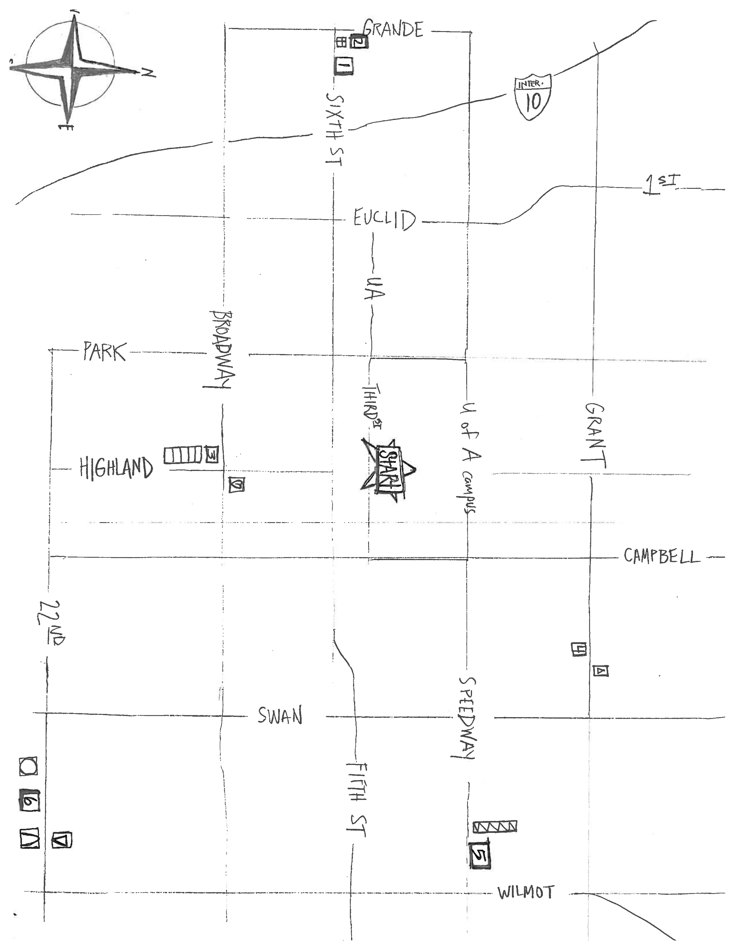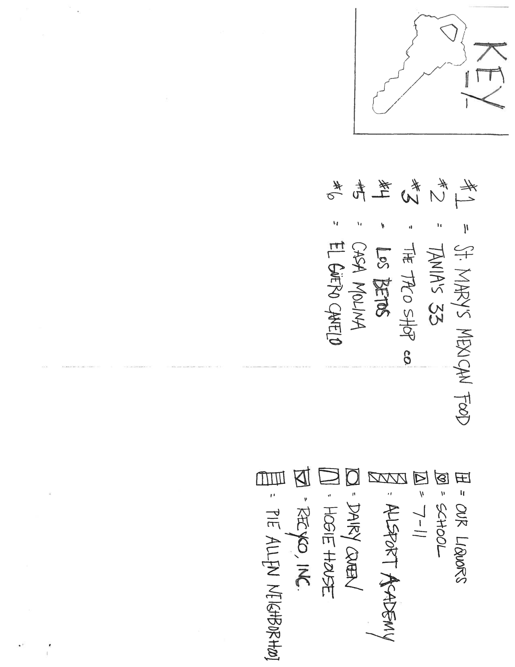

You may have to explain the idiom “Drive Blind”—that is, to do something you’ve never done before, without guidance.

